**Directory Al Imam Mohammad Ibn Saud Islamic University**

**College of Computer and Information Sciences**

**Information Technology Department**

|  |  |
| --- | --- |
| **Course Title:** | N-tier Architecture |
| **Course Code:** | IT 331 |
| **Course Instructor:** | Dr. Mnadour Mohaamad, D. Alsaddig Mohammad. T. Jomana Alhamidi T. Shatha Alkhaldi, |
| **Assessment:** | Project – Phase One |
| **Semester:** | First 2023 |
| **Due Date:** | Tuesday 4 Oct |
| **Duration:** |  |
| **Marks:** | 5 |

|  |  |  |  |
| --- | --- | --- | --- |
| **Group No.** | **Student Name** | **Student ID** | **Section No** |
|  | **Abdullah Saeed Al-Zahrani** | **440015940** | **172** |
| **Abdullah Mohammed Alnowaiser** | **439015025** |
| **Mohammed Mahfoudh Alkendi** | **439013123** |
|  |  |

|  |  |  |
| --- | --- | --- |
| **Official Use Only** | | |
| **Question** | **Student Marks** | **Question Marks** |
| 1 |  | 5 |
| **Total** |  | **5** |

**Project description:**

In this project you will build a 3-Tier Architecture Website in ASP.Net. The theme of the website is decided by the members of your project group. Each group will have 4 to 5 members, and each member should contribute equally to the project.

**Requirements:**

* Built a three-tier architecture website.
* Separating your project into three layers, presentation layer, Business Layer and data access layer, each layer should have meaningful name.
* Your website should not be less than 4 pages (Home, Login page etc).
* Each of those pages should use same or similar style, so that the pages look like they belong to the same website.
* Organize all pages in a good structure.
* Consistent navigation, for example if you have a menu which links to different pages, the menu should appear in the same place in all pages, so that users can easily find the menu and be able to navigate to different pages.
* **Your web application should be at least having two of the following features offered to the user: create a user account, search, reset the user password. modify the user information for the user page.**

**Submission:**

**To: upload to Blackboard**

1. All website files.

2. A report including:

* Students’ information (group number, name, id, and section number)
* A description of your project.
* Goal and objectives.
* Audience.
* Description of each page (not less than 4)

*Note: You can use any appropriate software other than ASP.NET*

description of project:

Our site sells a wide range of different cards, such as mobile cards, game cards and shopping cards. This allows users to easily obtain different credit cards in the easiest way.

Goal and objectives:

* Facilitate the possibility of obtaining different types of cards in the simplest possible way
* To add any type of card to help the largest category of customers.
* Offer the best and cheapest prices for all cards.

**Audience:**

Card Buyer / Explorer

**Description of each page:**

* Home:   
  This is the main page of the site and contains the site's logo and some other features, and the most prominent types of cards that are sold on the site are displayed, and there is also an email to communicate at the bottom of the page.

* About us:

We mentioned on this page an overview of the site, the date of its establishment and some news that was talking about the site and the method of approach used as well. Some of the services provided by the site and the extent of the site’s impact on the Middle East were mentioned. Finally, we mentioned the goal and purpose of creating the site.

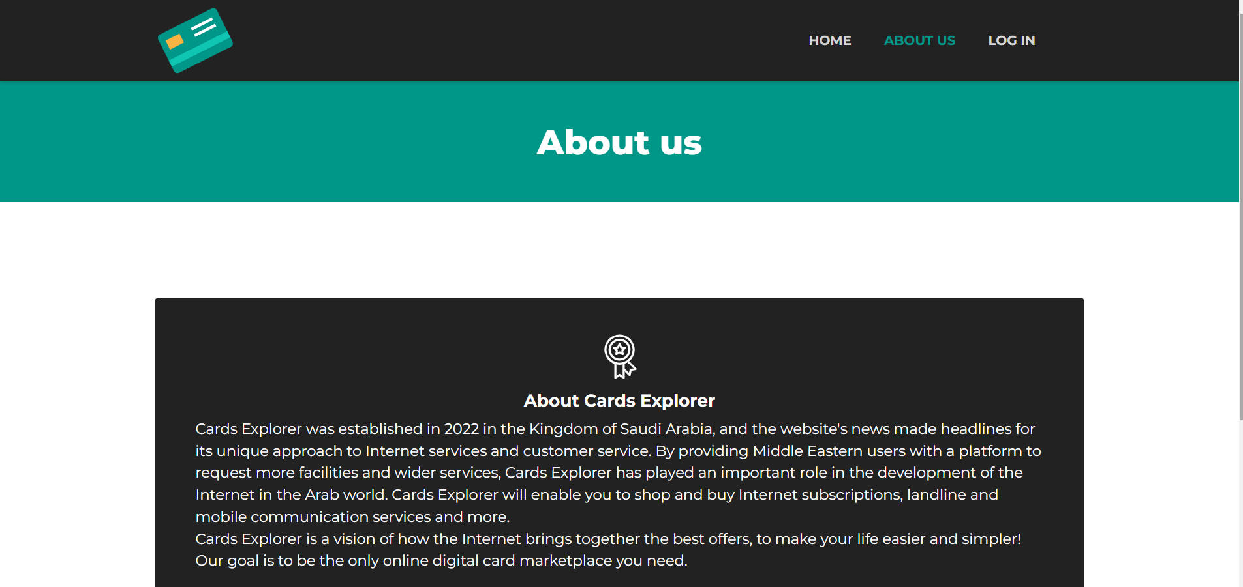

* Cards Category:

On these pages, the category of cards that are sold through the site are displayed, and each of these types displays 3 different types of cards.

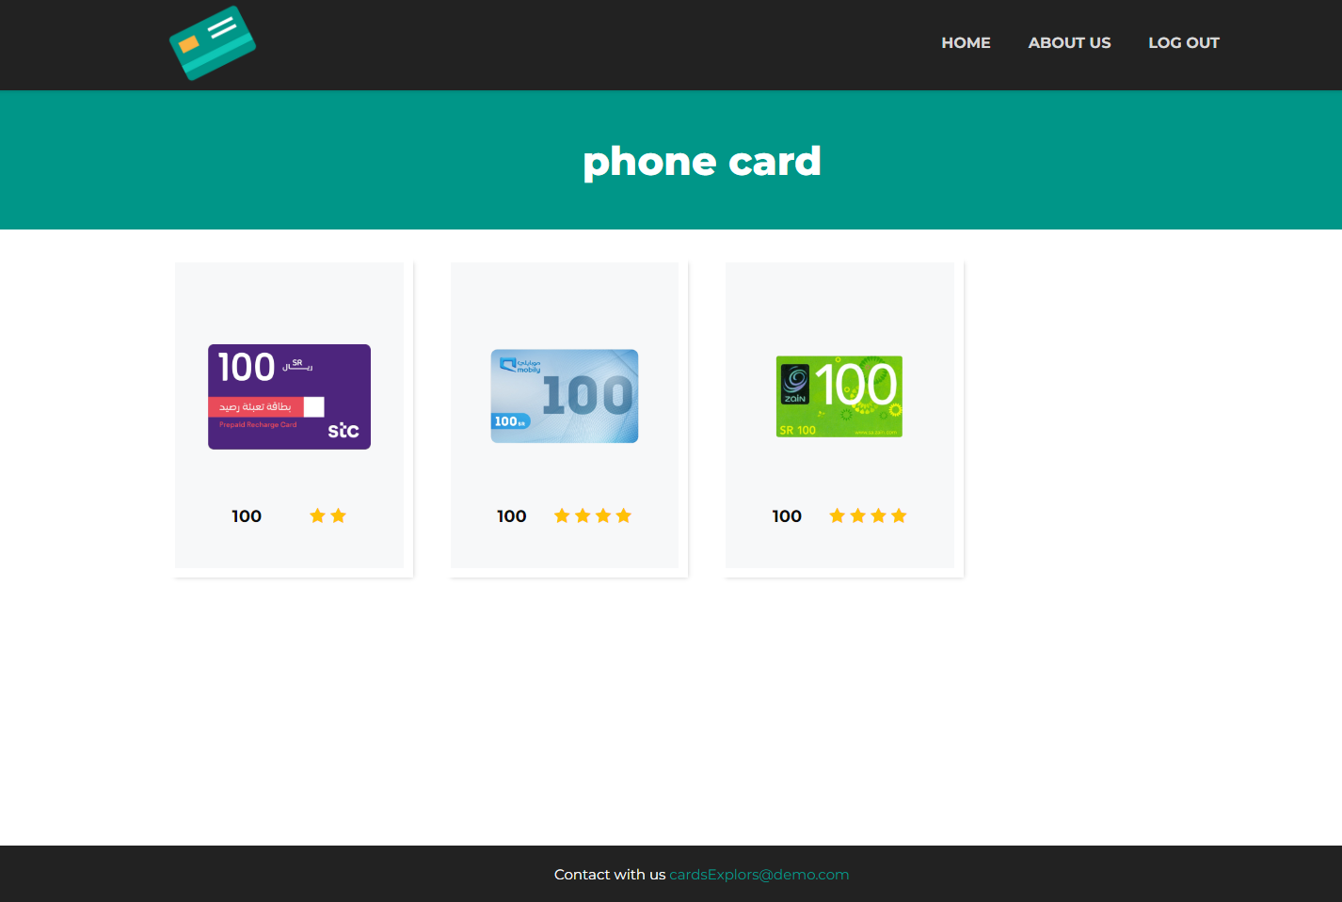

* Login:

The login page allows to access the control panel and add, edit, and delete cards.

* After Login:

All products on the site are displayed on this page and allows the admin to delete, add or make any modification to any product on the site.

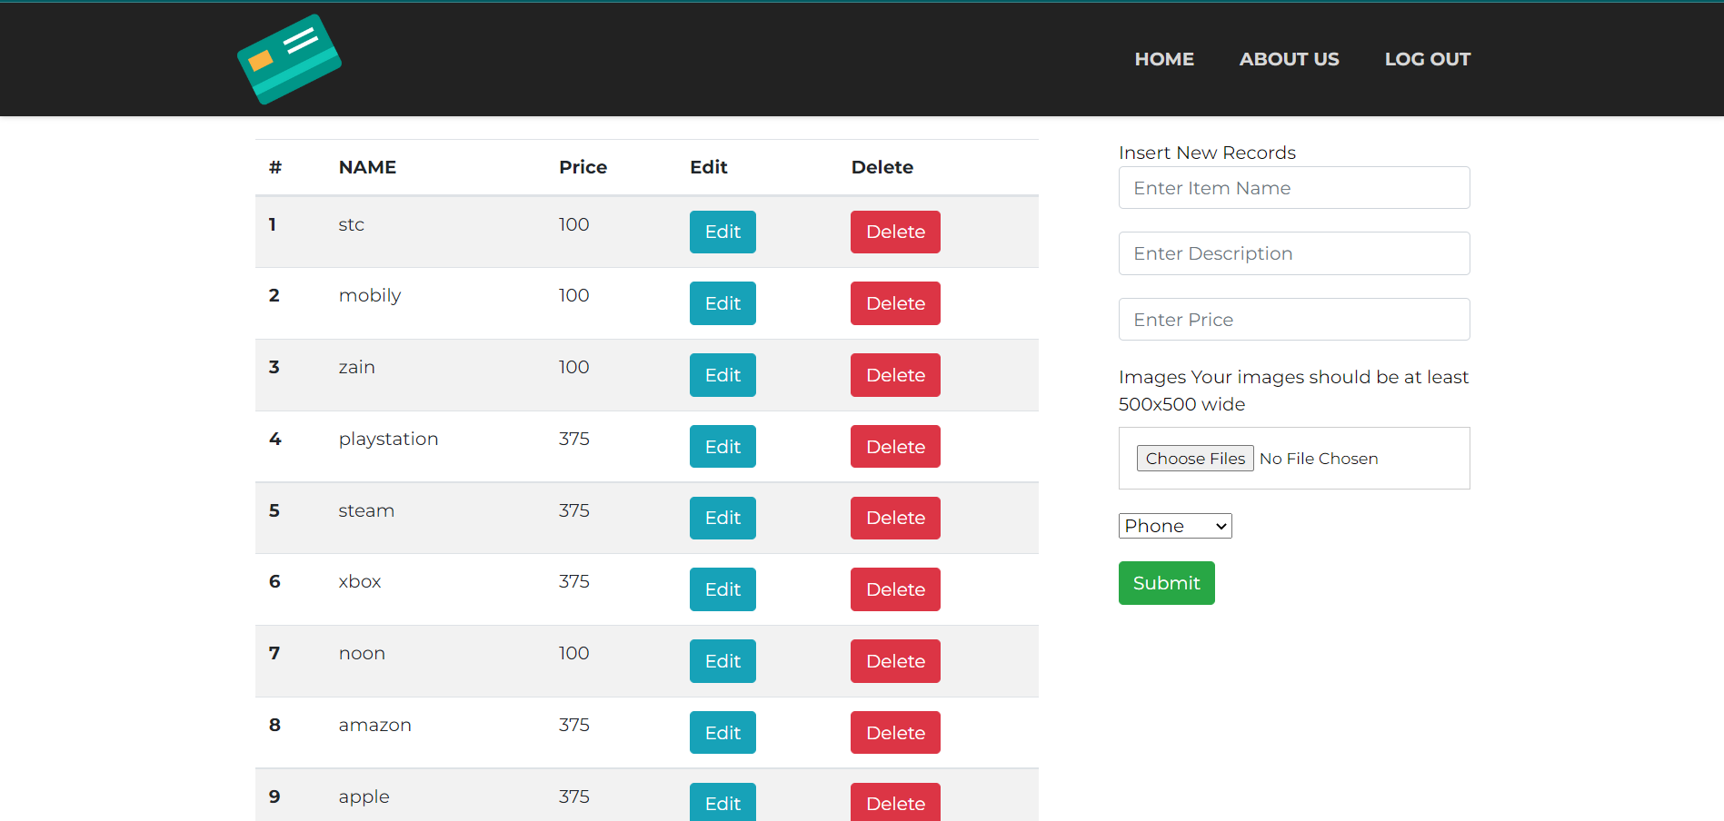

* Review For each Product While Sign in:

Users are allowed through this page to write a comment on the product or write the experience of purchasing the product from the site.

* Review For Each Product with Out Sign in:

* Registration page:

This page allows you to create a new username and password for new users of the site.

**Responsibilities and Coordination:**

|  |  |
| --- | --- |
| Group Member | Responsibilities |
| **Abdullah Mohammed Alnowaiser** | **Presentation Layer** |
| **Abdullah Saeed Al-zahrani** | **Business Layer**  **Data Access Layer** |
| **Mohammed Mahfoudh Alkendi** | **Presentation Layer, Report** |

**Phase one grading:**

|  |  |
| --- | --- |
| **Requirements** | **Points Possible** |
| Minimum of 4 pages  [Navigational Efficiency - Aesthetically Effectiveness] | 2 |
| Pages in a good structure. | 2 |
| Report. | 1 |
| **Total** | **5** |